Introduction to Databases CA 1

Marking Scheme

DDL Statements | DML Statements | Select Statements | Total  Marks
20 | 20 | 60 | 100

Overview:

Table 1: Sites | Table 2: Readings | Table 3: Counties | Table 4: Surveyors
Siteno (VARCHAR, 5) PRIMARY KEY | Siteno (VARCHAR,5) | Countycode (VARCHAR,5) PRIMARY KEY | Surveyorno (VARCHAR,5) PRIMARY KEY
Altitude (DECIMAL,20) | Readingno (DECIMAL,20) (PRIMARY KEY) | Countyname (VARCHAR,25) | Name (VARCHAR,50)
MapRef (VARCHAR,5) | Date (date/time) |  | Phone (VARCHAR,30) - INDEX
Countycode (VARCHAR,5) | Temperature (DECIMAL,20)
 | Humidity (DECIMAL,20)
 | Soilmoisture (DECIMAL,20)
 | SurveyorNo (VARCHAR,5)

SITES contains details on sites across the country and Siteno(text) is the primary key.

READINGS contains details on the readings gathered from each site, the primary key is Readingno.

COUNTIES contains details of possible counties sampled and Countycode is the primary key.

SURVEYORS contains details on contact info for the surveyors who took soil samples from the sites in various counties. The primary key is Surveyorno.

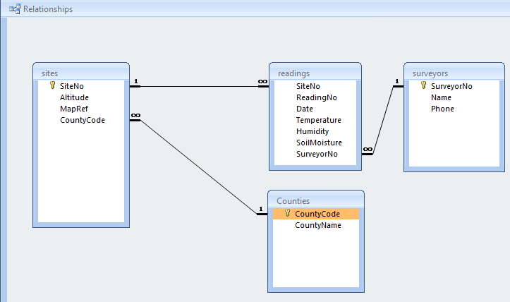
Section A: DDL
[Total 20 marks]

Q1: Write the DDL SQL commands showing the Data Types, to create the SITES, COUNTIES and SURVEYORS tables only from the details in the overview.

ANSWER1:
Use Database1;
Create Table sites(
Siteno Varchar, (5); Not Null
Altitude INT,(20);
MapRef Varchar,(5);
Countrycode Varchar,(5);

Create Table countries(
Countrycode Varchar,(5);
Countryname Varchar,(25);

Create Table surveyors(
Surveyorno Varchar,(5);
Name Varchar,(50);
Phone Varchar,(30);

[10 marks]

Q2: Write the DDL SQL commands to alter the tables as follows:
- Add a new column to SURVEYORS table called Email (Data Type: VARCHAR(75)
- Modify the column CountyName in the COUNTIES table and make it VARCHAR(50)

ANSWER2:
Use Database1;
INSERT INTO Surveyors,
CREATE TABLE ‘Email’, Varchar (75);

Use Database1;
UPDATE Counties;
SET Countyname = Varchar(50);
WHERE Countyname = Varchar(25);

[10 marks]

Section B: DML
[Total 20 marks]

Q3 Write the following DML Statements:

- Create four SQL insert statements to add a new record into each table
(4 Marks each)

ANSWER:
INSERT INTO Database1(Sites)
VALUES (Siteno, 5),

- Create an Update Statements (1 Mark) for the COUNTIES Table to Capitalise all county names
ANSWER:
UPDATE Counties
WHERE Names;
- Create an Update Statements (1 Mark) for the SURVEYORS Table to update the Phone field to ‘12345’ WHERE the name is equal to ‘Joe Bloggs’.
ANSWER:
UPDATE Surveyors;
WHERE Names = ‘Joe Bloggs’;

- Create Two Delete Statements (1 Mark each) on the READINGS table:
- Delete all records from the READINGS Table
- Delete the record that has a surveyorno equal to 101

ANSWER:
DELETE from Readings
SELECT *
SELECT Surveyorno = ‘101’;
Section C: Queries
[Total 60 marks]

Q4 Write SQL queries to do the following:
(a) List everything from the readings table with a date between 01/10/2010 and 01/12/2010
[6 marks]

ANSWER:
Use Database1;
SELECT COUNT (*) from Readings
WHERE Date = 01/10/2010 and 01/12/2010

(b) List SiteNo, CountyCode and CountyName of all sites listed in County Donegal.
ANSWER:
Use Database1;
SELECT CountyCode, and CountyName
FROM County Donegal,

[6 marks]

(c) List everything from the surveyors table whose names begin with ‘H’
ANSWER:
Use Database1;
SELECT * fname,lname
FROM Surveyors,
WHERE fname and lname LIKE’%H’

[6 marks]

(d) List all readings taken by Surveyor ‘Joe Bloggs’
ANSWER:
Use Database1;
SELECT * Readings
FROM Surveyors
WHERE Surveyorno = ‘Joe Bloggs’

[6 marks]

(e) List all Surveyors in ascending order.
ANSWER:
Use Database1;
SELECT * Surveyors
WHERE Surveyorno = ‘MAX’

[6 marks]

(f) List all readings that have a humidity less than or equal to 177
ANSWER:
Use Database1;
SELECT * Readings
WHERE Humidity = ‘< 0r = 177’

[6 marks]

(g) List all the readings from sites with a MapRef equal to 10210
ANSWER:
Use Database1;
SELECT * Sites
WHERE MapRef Varchar(5) =’10210’

[6 marks]

(h) Create a statement that counts the number of surveyors
ANSWER:
Use Database1;
SELECT COUNT (*) From Surveyors;

[6 marks]

(i) Create a statement that returns the minimum temperature recorded in the readings table
ANSWER:
Use Database1;
SELECT COUNT (*) From temperature
WHERE Temperature = ‘MIN’;

[6 marks]

(j) Create a statement that returns the last record in the sites table.
ANSWER:
Use Database1;
SELECT * From Sites
ORDER BY Sites Limit 1;

[6 marks]

